**AWS TASK**

1. Launch Instance in AWS Console Management. Enter name of the server and select Windows OS.

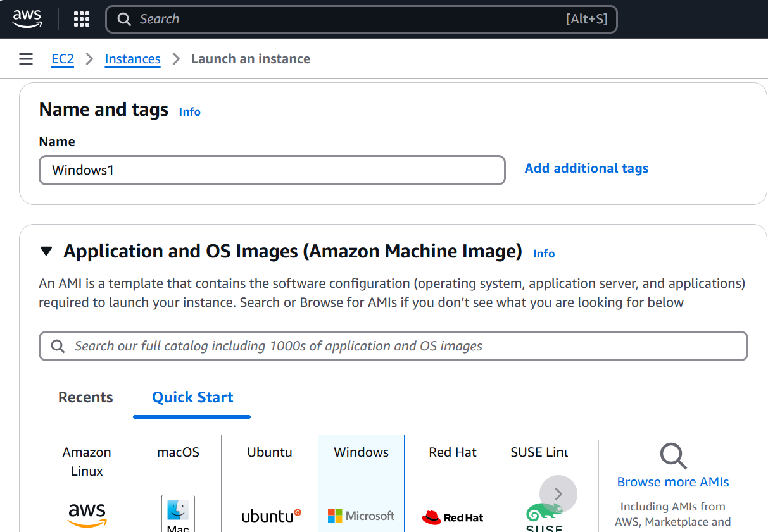

1. Select Server OS version and then Instance type as t3.micro

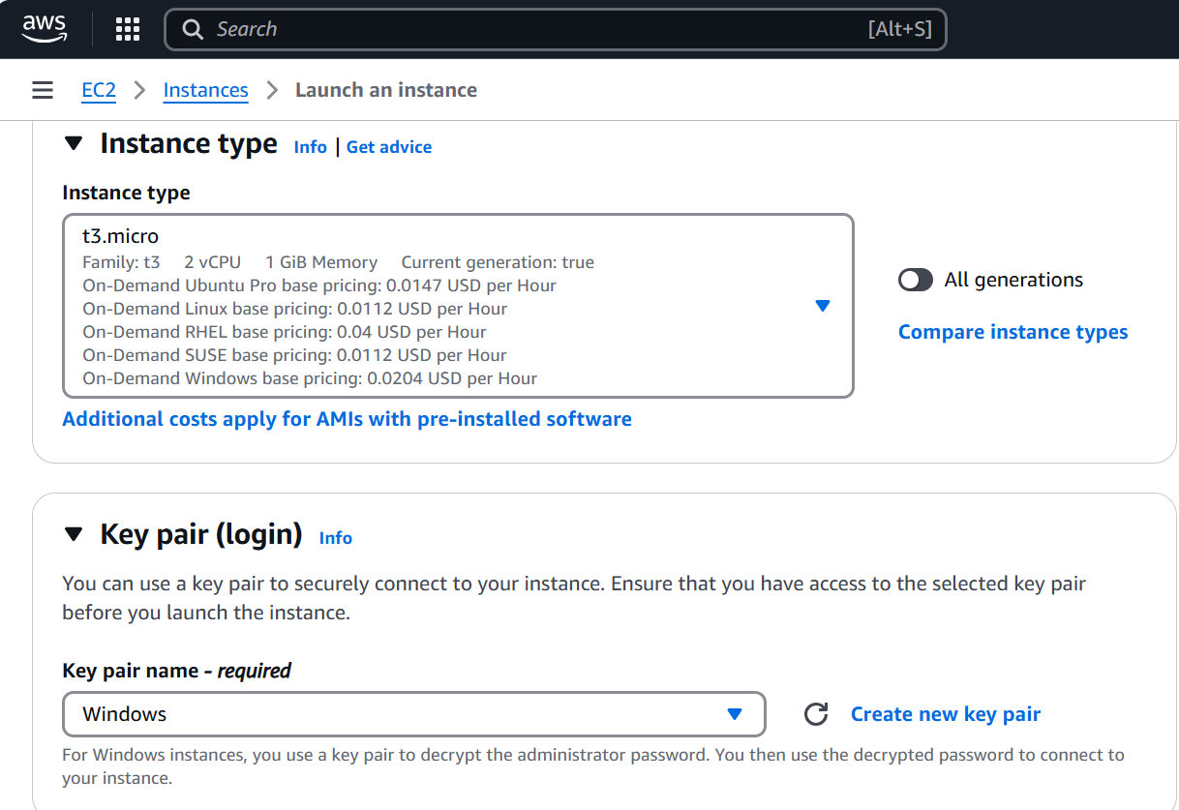

1. Create a new Keypair.
2. Under Network Settings create a new Security Group and allow RDP traffic from anywhere.

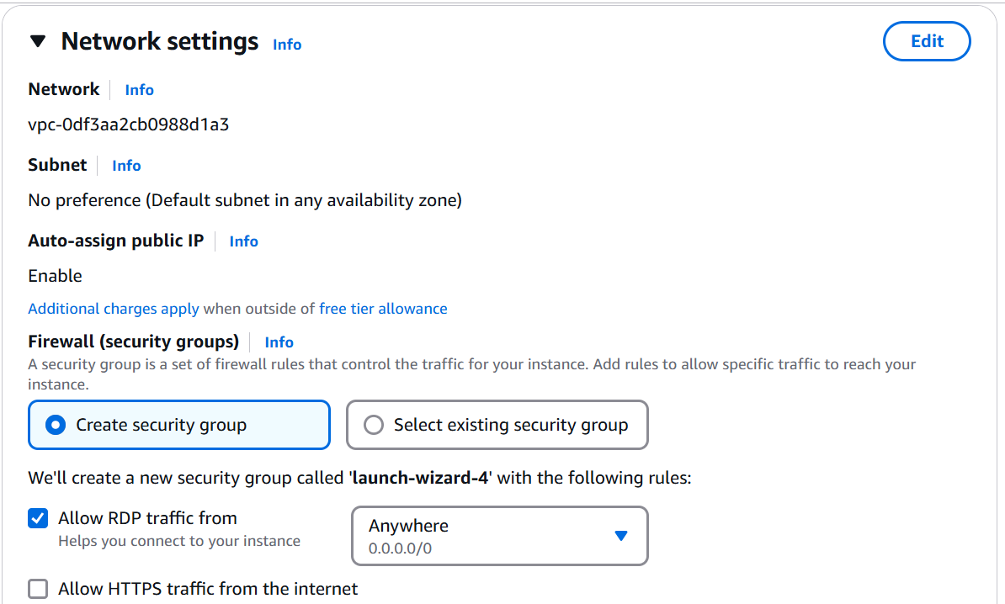

1. Launch instance and click on instance you have created -> actions ->Security -> Get windows password.
2. Upload the private key you have created and Click on Decrypt.

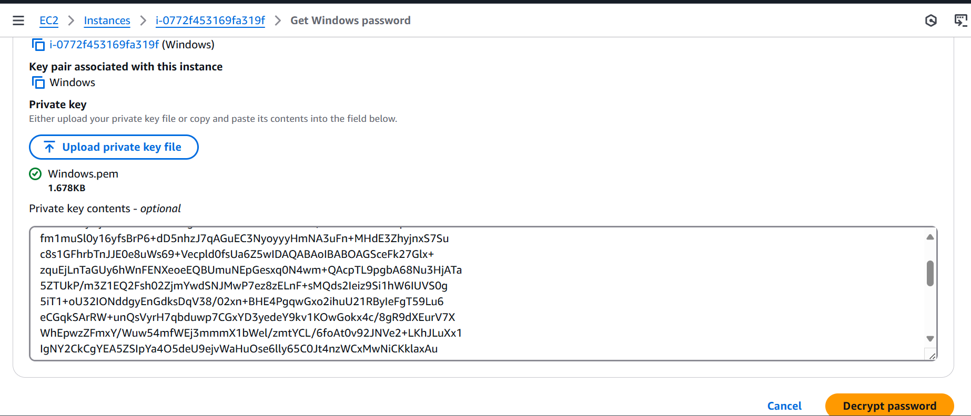

1. RDP using pulic IP address and Credentials you will get after Decrypt.
2. In CMD prompt type systeminfo to get all details of the server created.

